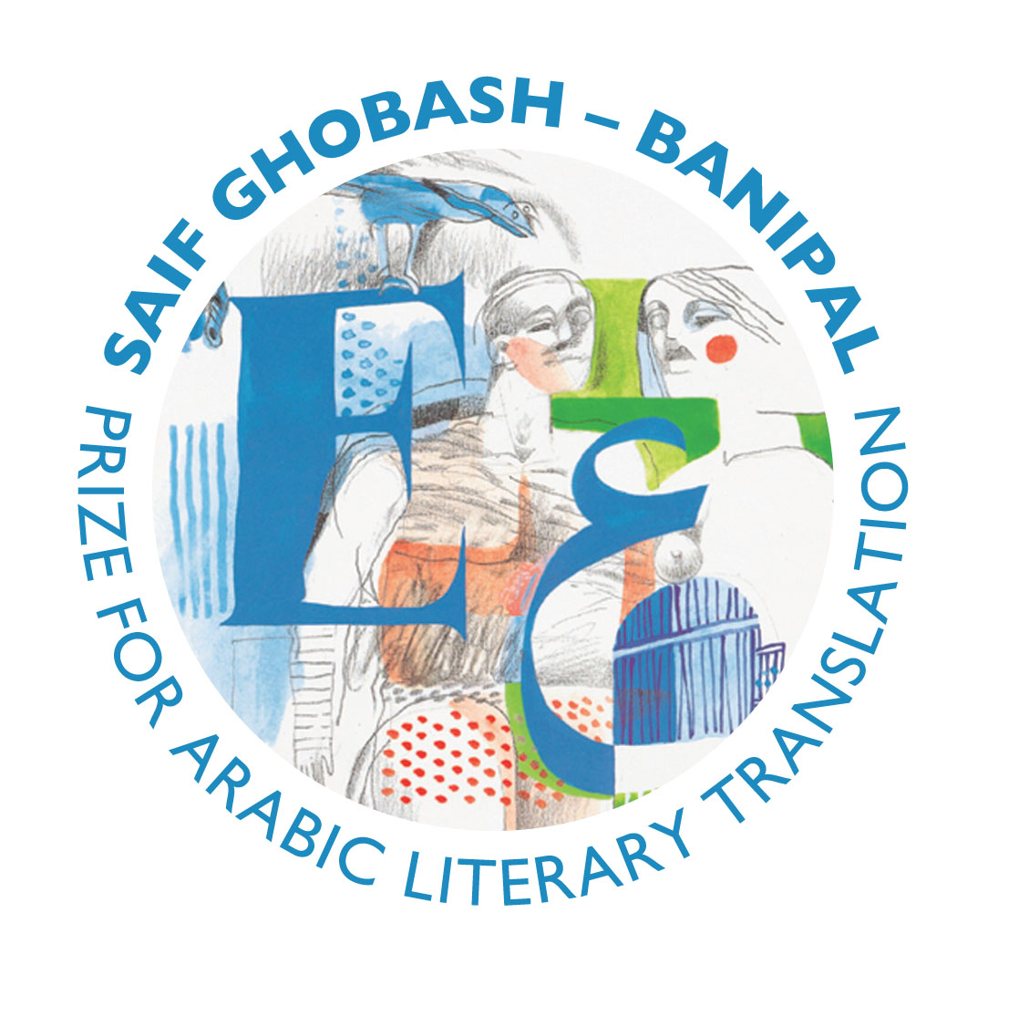
THE SAIF GHOBASH – BANIPAL
PRIZE FOR ARABIC
LITERARY TRANSLATION

The 2010 Prize for Arabic Literary Translation, the fifth year of the prize, is awarded to Humphrey Davies for his translation of the novel Yalo by Elias Khoury, published by Maclehose Press in the UK. Yalo was long-listed last year for the 2010 Independent Foreign Fiction Prize.

Humphrey Davies is also a runner-up this year for his translation of Sunset Oasis by Bahaa Taher, published by Sceptre, UK and recently nominated for the 2011 IMPAC Prize. A further runner-up is Kareem James Abu-Zeid for his translation of Cities without Palms by Tarek Etayeb, published by Arabia Books, UK.

The 2010 judges were author Margaret Drabble DBE, writer, translator and Professor of Comparative Literature at Warwick University Susan Bassnett, translator of contemporary Arabic literature of Georgetown University Elliott Colla, and on behalf of the Banipal Trust for Arab Literature Yasir Suleiman, Professor of Modern Arabic Studies and Head of the Department of Middle Eastern Studies at the University of Cambridge.

The Winner
Humphrey Davies for his translation of Yalo by Elias Khoury

On being told the news, Humphrey declared: “I’m over the moon. To win the Banipal Prize two-and-a half times in five years is indeed a signal honour.”

Elias Khoury was equally thrilled and told Banipal: “Congratulations to Humphrey. It is great that he has won the prize twice, and both times I have had the honour of accompanying his achievements with my two novels.”

Maclehose Press publisher Christopher MacLehose added: “It will give the author as much pleasure as it does his publisher that Humphrey Davies should have been awarded this distinguished prize for his second successive translation of Elias Khoury’s work. The award recognises a remarkable partnership and will give a welcome prominence to the fiction of an exceptional writer as also of his invaluable collaborator.”

What the Judges said

Yasir Suleiman:
“The judges were unanimous in their decision to award the 2010 Saif Ghobash-Banipal Prize for Arabic Literary Translation to Humphrey Davies for his translation of Elias Khoury’s novel Yalo. It was first choice on all the judges’ lists. Yalo is a captivating tale of a young man who is absorbed in his search for who he is. The reader joins Yalo on this journey of violence, sexual abuse, intrigue and fractured lives, moving between slender vignettes of reality and a surrealist world of self exploration tinged with doubt and tantalising uncertainties. Entering the world of Yalo is a revelatory experience in which the reader is kept guessing, asking questions, reaching conclusions and then having them dashed by the many twists and turns in the narrative in a way that almost mirrors Yalo’s self-exploration.

“Elias Khoury is a leading Arab writer whose work has been translated into English and other languages. His narratives are finely textured to create complex characters and nonlinear fictional worlds that are both captivating and intriguing. Crafted out of fragments of memory, Khoury’s narratives typically unfold in simple style that moves slowly before it picks up speed and develop into a galloping pace that carries the reader with.

“This is not the first time a novel by Elias Khoury wins the Saif Ghobash-Banipal Prize for Arabic Literary Translation. Gate of the Sun was the first winner of the Prize in 2006, which was also translated by Humphrey Davies. The judges this year were impressed by the sensitivity of the winning translation and its ability to take the reader into the inner recesses of Yalo’s mind and soul in an intimate way. The simple but exquisitely crafted prose lines create a narrative free of clutter which is sometimes present in translations of Arabic fiction. The authentic voice of the author comes through rather than that of a univocal translator who renders different texts in a near monochrome fashion.”

Margaret Drabble:
“This novel is a tour de force for both author and translator, an ambitious work which deals magnificently with the violence of history and the loss and uses of language, with torture and rape and sexuality. An important and complex book, which brings the history of Lebanon vividly, painfully and colourfully to life.”

Susan Bassnett:
This is a powerful, moving book that works on many levels. The device of flashbacks and retellings of the protagonist’s story is well-handled, and engages the reader’s attention from the outset, a task that shows the author’s skill, as the narrative becomes increasingly dislocated with the gradual disintegration of Yalo himself. The theme of the book is sombre, but the writing never deteriorates into sensationalism or prurience; rather Elias Khoury manages the difficult task of maintaining a kind of sympathy for Yalo, the alter ego of one Daniel Abyad, as we learn of his disfunctional family, the tragic mistakes of his life, his doomed relationships and his criminal tendencies. The translation is fluent and the language well-crafted. Once I started reading this book, I found it compulsive and it went straight to the top of my list of winners.

Elliott Colla:
“With Yalo, Elias Khoury once again confirms his pre-eminent reputation among contemporary Arab writers. This is not merely a novel – it is a politically charged and philosophically nuanced interrogation of what literature can and cannot do with regard to histories of violence, and the answers it renders are disturbing. Humphrey Davies’s seamless translation hides the skill with which he works here. The language of this novel is notoriously difficult. Davies renders this difficulty in a fluent British idiom, but never at the expense of the complexities of the original.”

Runner-up
Humphrey Davies for his translation of Sunset Oasis by Bahaa Taher

What the Judges said

Yasir Suleiman:
“The judges had the good fortune of comparing the translation of Yalo with Bahaa Taher’s Sunset Oasis, also translated by Humphrey Davies, which was chosen by the judges as one of two runners-up in 2010. The two translations could not be more different. They spoke in different voices that reflected the distinctiveness of their Arab authors. This is a tribute to the virtuosity of Humphrey Davies as one of the best translators of Arabic fiction into English.

“Sunset Oasis was the winner of the International Prize of Arabic Fiction (IPAF) in 2009. The novel provides a powerful narrative of Egyptian society at a crucial point in its modern history. Its clean and powerful narrative lines and the full grasp of the historical background against which the events of the novel unfold create a gripping story of love, intrigue, social unrest and tragedy.”

Margaret Drabble:
“This is a profound, subtle and resonant novel by one of the Arab world’s greatest writers. It interweaves the colonial histories of east and west, moves effortlessly between historical periods, and creates, in the oasis, a memorable and elegiac image of the ruins of time. It is sensitively translated, and the English reader can sense the poetry of the original.”

Susan Bassnett:
“A gripping many-stranded narrative that engages with memory, history, politics and love. I read it in a single sitting, as the fast pace and carefully constructed plot lines held my attention and compelled me to keep on turning the pages. The translation is strong, though with occasional lapses into a more banal language, which kept it from being in first place for me.”

Runner-up
Kareem James Abu-Zeid for his translation of Cities without Palms by Tarek Etayeb

What the Judges said

Yasir Suleiman:
“The other runner-up is Cities without Palms by the Sudanese writer Tarek Eltayeb, translated by Kareem James Abu-Zeid. This slender but moving novel is reminiscent of Tayeb Salih’s well-known classic Season of Migration to the North, though in no way is it a parody or copy. Migration and its traumas, the passage into adulthood and the cruel hand of fate combine together to create a haunting tale of great sympathy that once started is hard to put down until the end.”

Margaret Drabble:
“This is the deceptively simple but emblematic tale of a village boy from the Sudan who travels to the cities of the north and the west and then home again. It rings true on every page, and the contrasts of rural and city life are tellingly described. This is a story of our time, told with insight and sympathy, in a simple prose that the translator renders skilfully and unobtrusively into everyday English.”

Susan Bassnett:
“A moving short novel by a new writer, which recounts the journey of a young Sudanese man who leaves his village for Cairo, then travels to Europe in search of a better life. Told in the first person, the novel has a minimalist quality, and I felt that it would make a strong one-man stage piece, as the quality of story telling is so good. Though the novel takes us through stages of disappointment as hopes are crushed, the bleakness of the ending still came as a stark and chilling coup, and left me very moved. This is a novel that should surely serve to raise awareness of the tragic journeys that so many young people embark on all over the world every day in this globalised world of savage inequalities. The translation reads fluently, the plainness of the writing reflecting the simplicity of the central character.”

Celebrate the fifth year of the Saif Ghobash–Banipal Prize
for Arabic Literary Translation 2010 Award with two events

Monday 31 January
7pm, King’s Place, 90 York Way, London N1 9AG

The Translation Prizes Award Ceremony
with readings and prizes presented by Sir Peter Stothard
and the Sebald Lecture on the Art of Literary Translation
given by Ali Smith and entitled “Loosed in Translation”

Tuesday 1st February

The Banipal Trust for Arab Literature and The Mosaic Rooms
invite you to celebrate

The 5th year of the Prize and its 2010 winner Humphrey Davies

at a Reception and Conversation with the winner
chaired by André Naffis-Sahely

6.30pm for 7.00pm
The Mosaic Rooms (A.M. Qattan Foundation)
226 Cromwell Road (jcn with Earl’s Court Road)
London SW5 0SW

Copies of Yalo will be on sale.

This is a free event, but with limited seating. Please reserve your place to avoid disappointment by emailing info@mosaicrooms.org or phoning 0207 370 9990

Getting there: Tube: Earl’s Court, Earl’s Court Road exit. Buses: 74, 328, C1, C3
The Saif Ghobash – Banipal Prize is administered by the Society of Authors in the UK, together with a number of well-established prizes for literary translation into English from European languages, such as the prestigious Scott Moncrieff Prize for translation from French. The Award Ceremony is hosted by the British Centre for Literary Translation, the Arts Council, and the Society of Authors. The annual prize of £3,000 is awarded to the translator of a published translation in English of a full-length imaginative and creative Arabic work of literary merit published in the thirty-five years prior to submission of the translation and first published in English translation in the year prior to the award. Entries can have been published anywhere in the world but must be available for purchase in the United Kingdom, either via a distributor or on-line. The prize, the first specifically for a published work of English literary translation from Arabic, was established in 2005 by Banipal, the magazine of modern Arab literature in English translation, and the Banipal Trust for Arab Literature, and is now sponsored by Omar Saif Ghobash in memory of his father, the late Saif Ghobash, a man passionate about Arabic literature and other literatures of the world.
_____________________________________________________________________________________

For more information. or to arrange an interview with Humphrey Davies, please contact
The Banipal Trust for Arab Literature
1 Gough Square, London, EC4A 3DE
Tel: 00 44 (0)20 7832 1350 Email: info@banipaltrust.org.uk www.banipaltrust.org.uk

